**Salesforce Project Implementation Phases**

**Phase 6: User Interface Development**

In this phase, I have build the **UI layer** of my Telemedicine Salesforce project. The goal is to design intuitive Lightning Pages and extend them with **Lightning Web Components (LWC)** connected to Apex for dynamic features.

* **Lightning App Builder**

Tool: Setup → Lightning App Builder.

- Create custom pages for **Doctor Dashboard**, **Patient Portal**, and **Pharmacy**

**Management**.

- Add components (Record Details, Related Lists, Charts)

- Assign to Apps, Record Types or Profiles

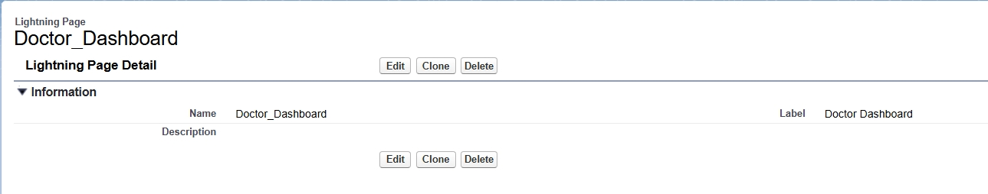

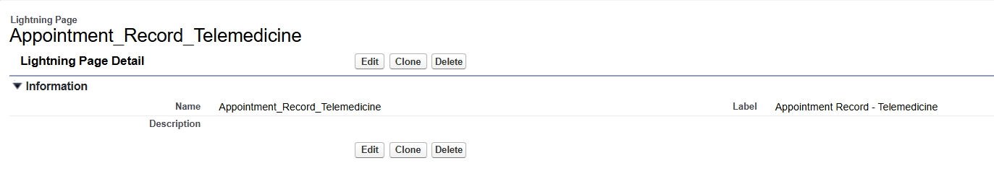

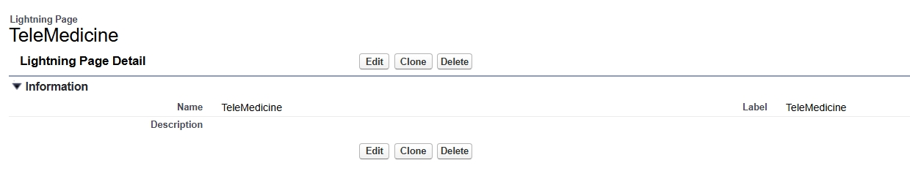

* **Record Pages**

Customize **Appointment__c Record Page** to show:

- Appointment Details (Time, Doctor, Patient).

- Related List for Prescription__c.

- Custom LWC for “Reschedule Appointment”.

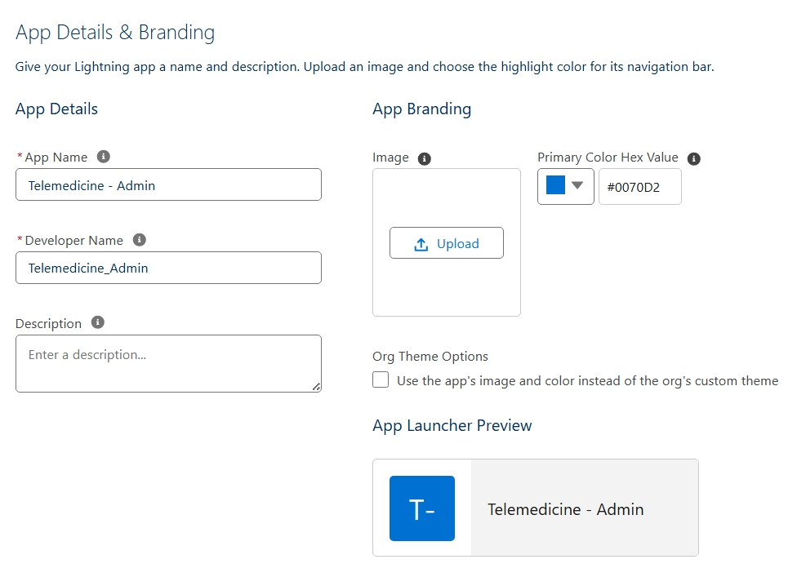

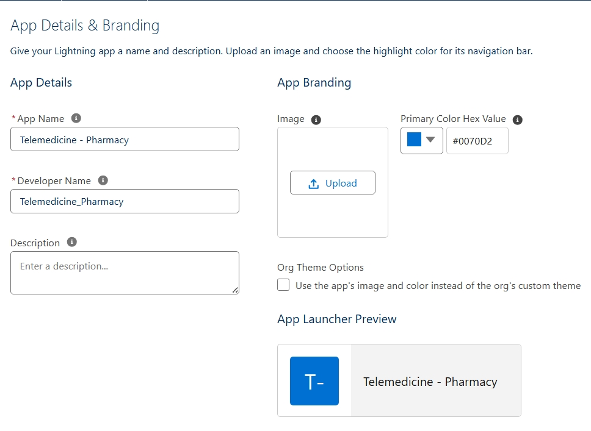

* **Tabs**

Add **Custom Tabs** for:

- Appointment__c

- Prescription__c

- Purchase_Order__c

- report__c

- Medicine_inventory__c

- Error_log__c

- Patient__c

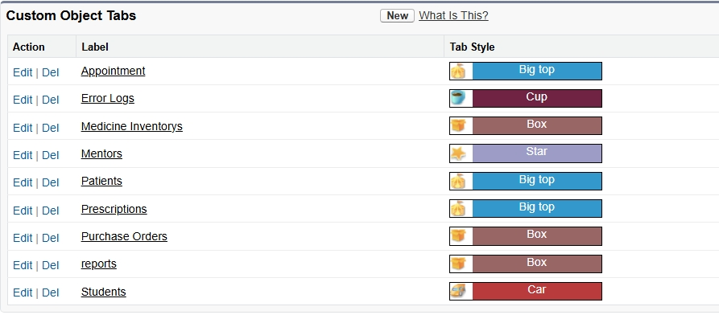

Tabs help users access records easily from the App Launcher.

* **Home Page Layouts**

Modify Home Page for **Doctors**:

- Component: Today’s Appointments (List View).

- Component: Recent Patients.

- Dashboard (Appointments by Status).

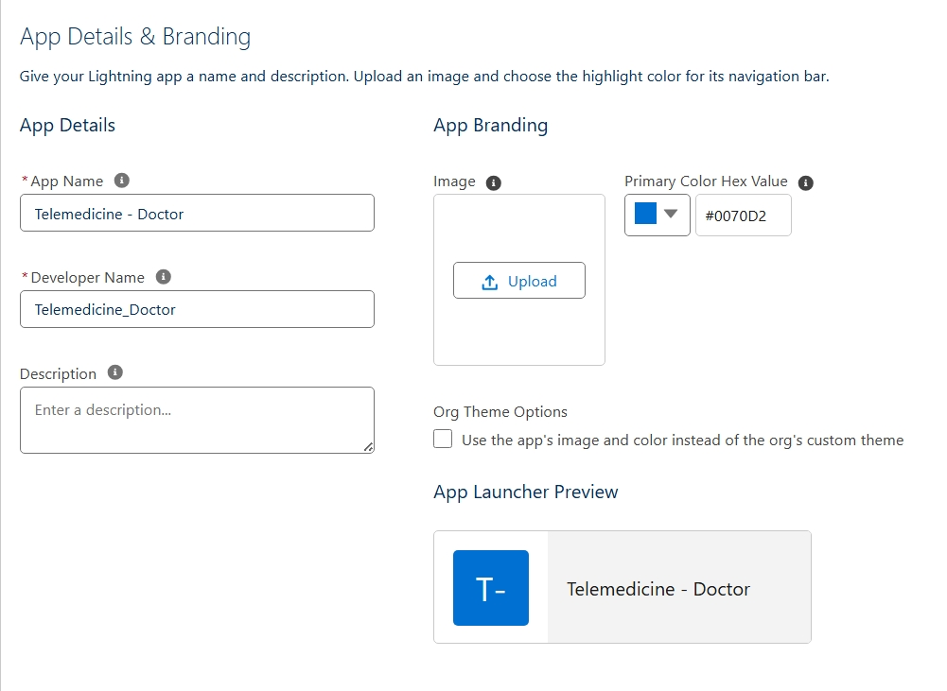

Modify Home Page for **Patients**:

- Component: Upcoming Appointments.

- Component: My Prescriptions.

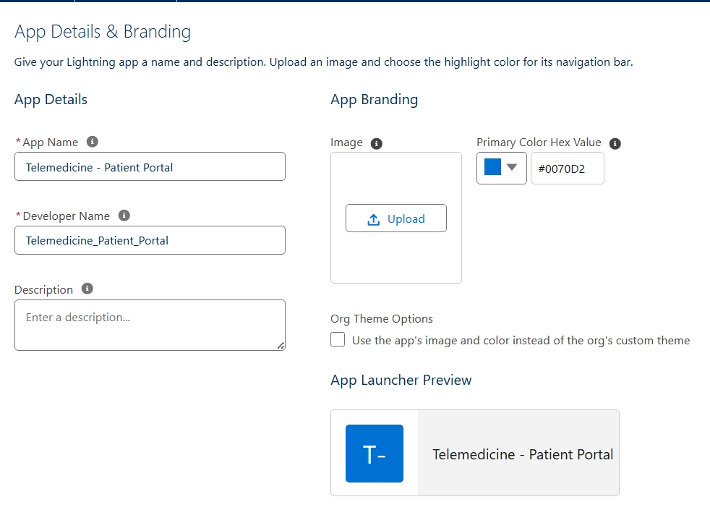

* **Utility Bar**

Add Utility Bar in the Doctor’s App:

- Quick Actions : Create Appointment

- Chat (Future Integration)

- Notes

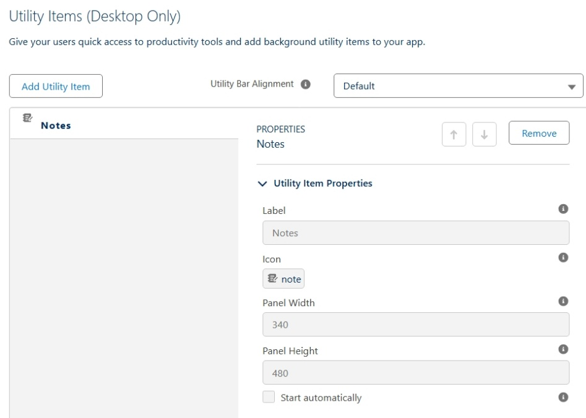

* **LWC (Lightning Web Components)**

Custom components built for our project:

- **AppointmentCard** → Display patient + doctor appointment details.

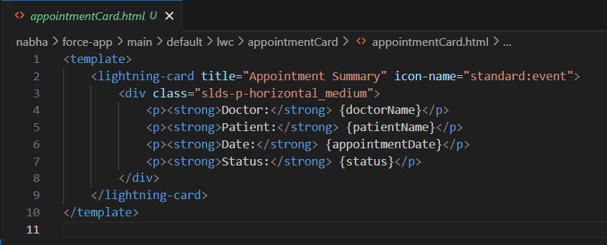

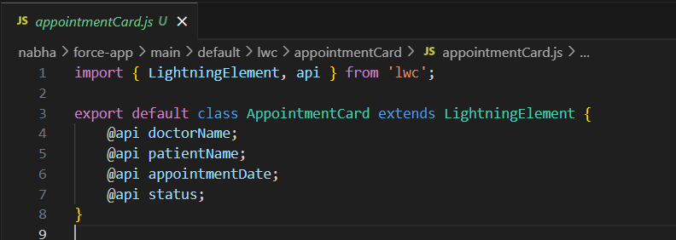

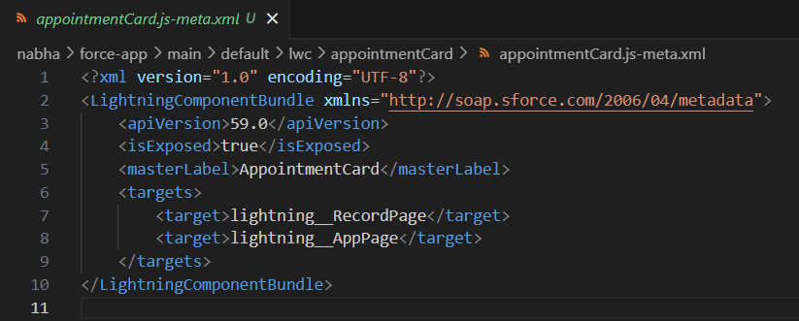

- **PrescriptionForm** → Capture medicines and dosage.

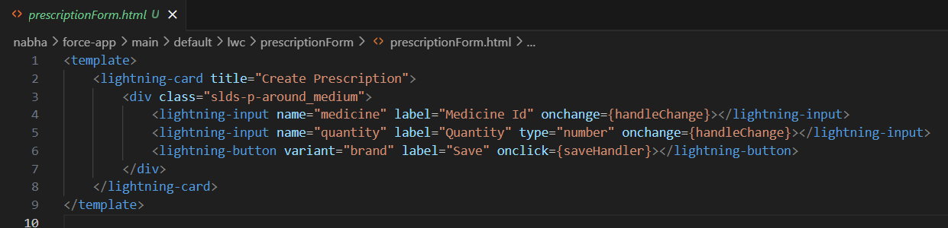

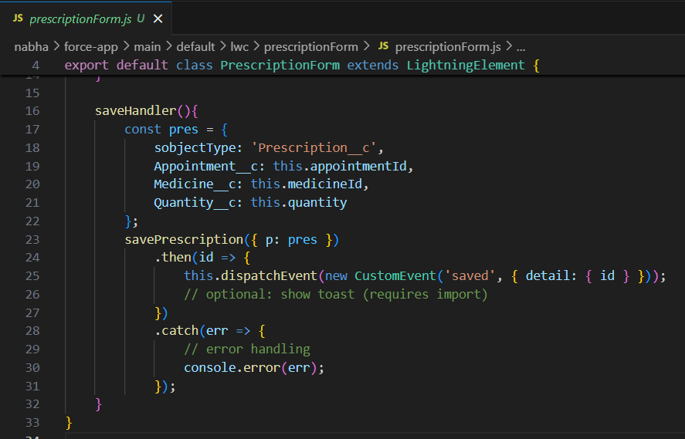

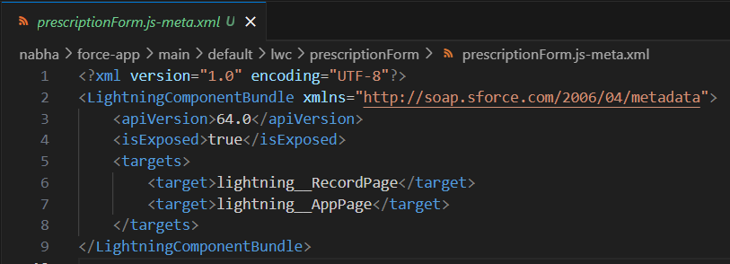

- **PurchaseOrderTracker** → Show Purchase Orders with Pharma Suppliers.

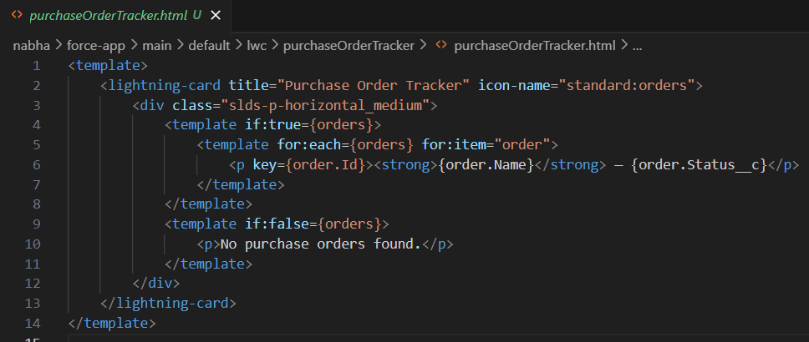

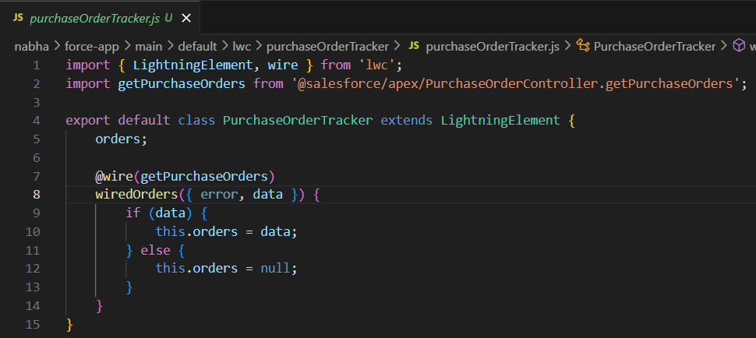

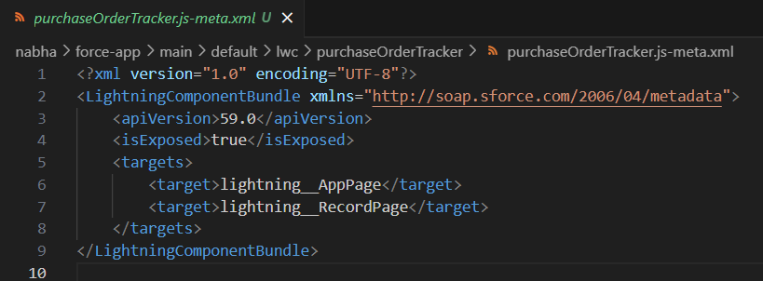

* **Apex with LWC**

Call Apex class TelemedicineService from LWC to:

- Fetch appointments for logged-in doctor.

- Save a new prescription.

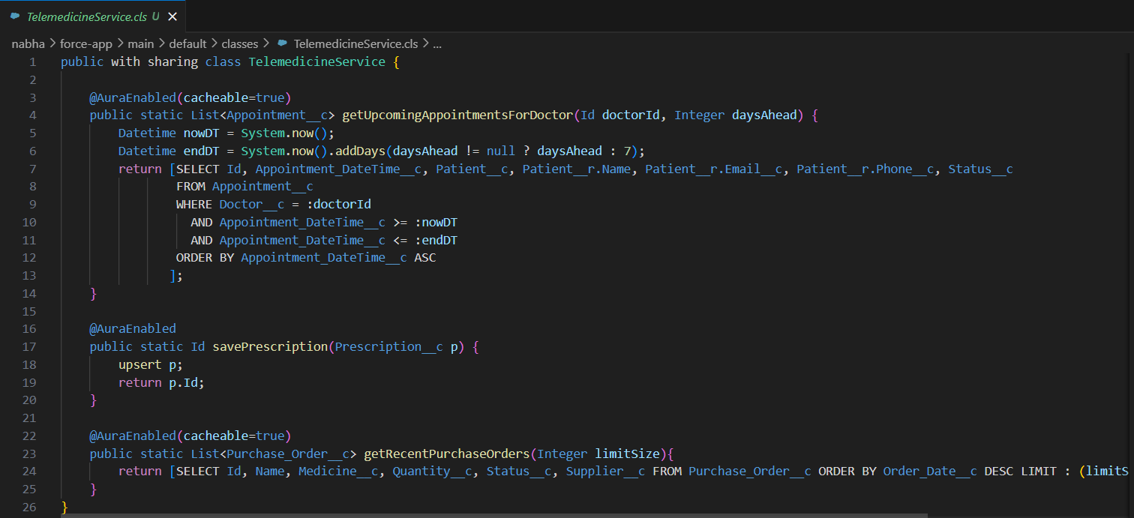

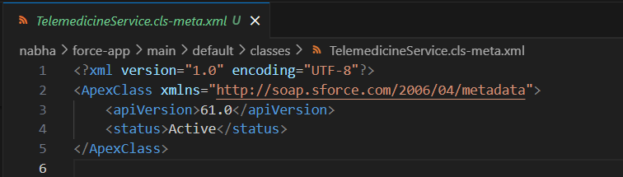

* **Events in LWC**

Use events for communication:

- **Child → Parent**: PrescriptionForm sends “PrescriptionSaved” event to parent

component.

Child dispatches CustomEvent('saved', { detail: { id } }) after saving. Parent

component listens:



- **Parent → Child**: Refresh AppointmentCard when appointment is rescheduled.

Parent handleSaved(event) can refresh list or call this.template.querySelector('c-

appointment-card').loadAppointments().

* **Wire Adapters**

Use @wire with Salesforce data:

- @wire(getRecord, { recordId: '$recordId', fields: [...] }) for Appointment record.

- @wire(getListUi, { objectApiName: 'Appointment__c', listViewApiName: 'All' }) to

show appointments in UI.

* **Imperative Apex Calls**

In AppointmentCard LWC:

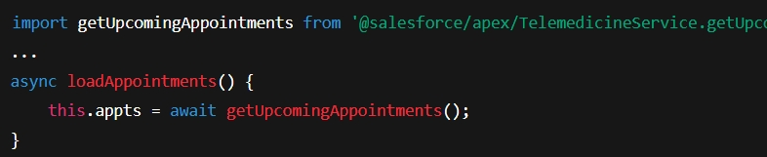

* **Navigation Service**

Use NavigationMixin in LWCs to redirect:

- Navigate from AppointmentCard → Appointment Record Page.

- Navigate from Patient → Related Prescriptions.

**Deliverables in Phase 6**

* Custom Record Pages for Appointment, Prescription, Patient.
* Custom Tabs and Home Pages.
* Utility Bar for Doctor App.
* LWC components (AppointmentCard, PrescriptionForm, PurchaseOrderTracker).
* Apex integrated with LWC (Wire + Imperative).
* Navigation between components.